The Guild of the Champaign-Urbana Symphony Orchestra UIUC Historic Coverlets
Make Great Gifts!

CUSO Guild coverlets make great gifts for your family and friends who have a loyalty to the University of Illinois. Coverlets are the perfect commencement, new faculty & staff, alumni, retirement, or holiday gift. Let us help you with your holiday and commencement gift shopping, the easy way!
Coverlets depicting many famous buildings on the UIUC campus are now available and will be delivered to your home. These lovely coverlets are 50” by 70”, 100% cotton, pre-shrunk and machine washable.
Proceeds from the sale of coverlets by the Champaign-Urbana Symphony Orchestra Guild provide continuing support for the programs and performances of CUSO and CUSO music education programs for the children of our communities.
Each coverlet is $80.00. To order a coverlet, complete this order form and send it to Penny Porter, 509 W. John St., Champaign, IL 61820, Tel. 217-390-7247, Penny.Porter48@gmail.com.
We will deliver it to your home if you live in CU. If not, please add a $10.00 shipping charge. Make checks payable to the Champaign-Urbana Symphony Orchestra Guild. Thank you!
Coverlet Order Form
Name_____________________________________________Phone_______________________
Address________________________________________________________________________
Email Address___________________________________________________________________
Credit card # ____________________________________ Exp (MM/YY) ____/___ CSV________
Quantity ________ Total dollar amount $ _____________ Donation: ________
Continued….

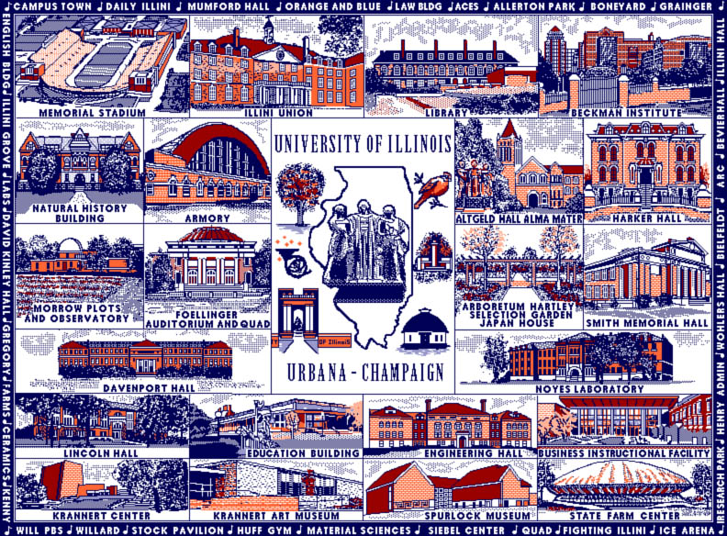

In 1862, the Morrill Land-Grant College Act was passed by congress and signed by Abraham Lincoln. This legislation authorized the founding of educational institutions across the nation and paved the way for the University of Illinois and others.
Culminating years of effort by the local citizens to locate the state university in Urbana-Champaign, the bill creating the new University was signed by Governor Richard J. Oglesby on February 28, 1867. On March 11, 1868, the Illinois Industrial University formally opened with John Milton Gregory as the first regent and a class of 77 male students. By 1880, there were 4 colleges: Agriculture, Engineering, Natural Sciences, and Literature and Science. In 1885, the name of Illinois Industrial University was changed to the University of Illinois.

9/27/2021 edition

